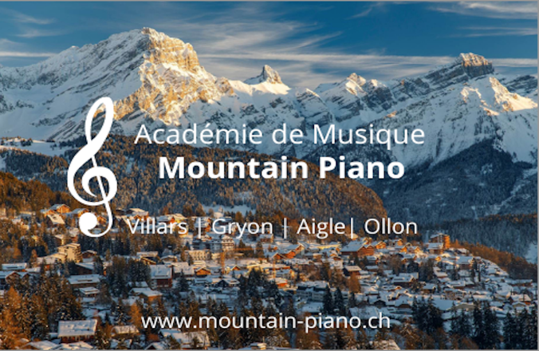
École de Musique Mountain Piano
Académie de Musique Mountain Piano
Making Music Addictive!
Locations in Villars, Gryon, Chesières and Aigle

E-Mail: piano.villars@gmail.com
Site: www.mountain-piano.ch

Date: 28.2.22

Teaching Approach – INTERMEDIATE PIANO STUDETNS
​
Teaching intermediate level students (particularly when they started as a beginner with us) is a hugely rewarding progress, particularly when seeing the student progress through the hurdles, books and grades from day one!
​
For intermediate level students of all ages, we offer 45- or 60 minute lessons. The lessons can occur in one of our locations in the Villars/Gryon/Aigle area.
​
Our approach for intermediate students vary and are catered to the student, but some general highlights include:
- Guaranteed progression from the first lesson
- Specific Exam training (e.g. ABRSM, Trinity)
- Two concerts per year and other potential performance opportunities
- Prices in line with national recommendations, access to school scholarship fund if needed
- Group collaboration opportunities
- Piano & Keyboard rental and purchasing opportunities

Some testimonials from intermediate students:
- ‘I listened to a recent teaching session in our house, and I was impressed. As a result of his teaching style, which is very much child led, my daughter has done extremely well. Finding a replacement as we have moved abroad will be hard’, Tania, Parent
- "Nous, comme parents, recevons des commentaires réguliers (quelquefois écrit et de temps en temps aussi dans une manière informelle) du formation de nos deux enfants chez Mountain Piano à Villars. Et surtout, la prof a pris grand soin les soirs d'hiver, que mes enfants peuvent rentre à la maison en toute sécurité.’, Corinne, Parent of two students, Gryon
- ‘If you are looking for a piano teacher for children, the team at Mountain Piano are the best people! Family of two students, Chesières
- "I continue to make great progress here at Mountain Piano, with a great and supportive teacher. And I get lots of opportunities such as concerts that help me improve learning piano.", Felix, intermediate level student, Villars

Contact details:
- E-Mail: piano.villars@gmail.com
- WhatsApp/Message (thank you for organising a time to call us rather than calling us directly) : +41 79 105 86 47

