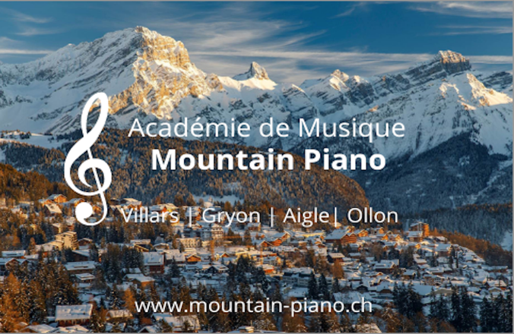
École de Musique Mountain Piano
Académie de Musique Mountain Piano
Making Music Addictive!
Locations in Villars, Gryon, Chesières and Aigle

E-Mail: piano.villars@gmail.com
Site: www.mountain-piano.ch

Date: 28.2.22

Testimonials – Student & Parents

We have sorted this non exhaustive list of testimonials into four categories :
- Testimonials from parents and younger piano students in the local area
- Testimonials of Adult Piano Students
- Testimonials from advanced piano students
- Testimonials from coaching or master-class participants

- Testimonials from parents and younger piano students in the local area
- ‘I listened to a recent teaching session in our house, and I was impressed. As a result of his teaching style which is very much child led, my daughter has done extremely well. Finding a replacement as we have moved abroad will be hard’, Vanessa, Parent, Chesières
- "Nous, comme parents, recevons des commentaires réguliers (quelquefois écrit et de temps en temps aussi dans une manière informelle) du formation de nos deux enfants chez Mountain Piano à Villars. Et surtout, la prof a pris grand soin les soirs d'hiver, que mes enfants peuvent rentre à la maison en toute sécurité.’, Corinne, Parent of two students, Gryon
- ‘If you are looking for a piano teacher for children, the team at Mountain Piano are the best people! Family of two students, Chesières
- "I continue to make great progress here at Mountain Piano, with a great and supportive teacher. And I get lots of opportunities such as concerts that help me improve learning piano.", Felix, intermediate level student, Villars
- My son loves lessons with his teacher at Mountain Piano. Being so young he is difficult to teach and after trying a couple of other teachers with no progression, we tried lessons with Sam, head and teacher at Mountain Piano. Since then, he has performed at a concert (despite being only five years old),and loves lessons so much that he now has two to three a week!’, Mother of beginner student, Villars
- ‘During the Pandemic, which is still with us now, Mountain Piano saw to it that guidelines and advice set out from the Swiss Federal Health authorities, was followed strictly.’ Parent, Villars
- ‘Thank you for all the new things you’ve taught us on the piano. We really appreciate it, we really like the lessons you prepare for us. Thank you!’ From two students, Villars
- ‘He very much enjoys his teachers teaching style and has made impressive progress in a short amount of time’, Beginner student, Villars

- Adult students
- ‘My dream of performing a piece I had self-taught myself during lockdown on a grand piano in a concert hall came true! I thoroughly enjoyed the opportunity and am eternally grateful to the Mountain Piano team for facilitating it, and look forward to performing at many more concerts and improving my pianistic abilities for many years to come with them! Adult student, Gryon
- ‘Sam’s teaching has been outstanding. He is patient, kind, thoughtful and professional in his approach.’, Tania, Parent
- ‘As an adult beginner, I needed to find an incredibly patient teacher, as well as one that could be very flexible with times as I also work and have children. The team at Mountain Piano were able to facilitate my needs and I really enjoy my lessons, and am making great progress!’ Nina, Adult student, Villars

- Advanced students
- ‘Sam and his team at Mountain Piano are highly regarded in the area and are highly skilled at what they do. The school attracts an outstanding caliber of teachers to teach at their school- alongside successfully delivering high-quality services to demanding international schools and students alike.’ Advisor to Mountain Piano, December 2021
- “The innovative, student-led, yet traditionally grounded teaching approach of my teacher at Mountain Piano is one to be admired, but equally to be taken great advantage of! He has been an excellent teacher and general mentor for me and couldn’t recommend and thank him more!”, Ritam, advanced student
- Oustanding advice and guidance on my advanced repertoire is standard from my teacher.
- Countless exam success stories- contact us for performance excerpts or to get refrerences from successful students themselves

- Coaching sessions
- Their coaching team now consists of three, highly-qualified, skilled and highly-experienced (75+ years combined!) members, who through this can guarantee progression for all students, and boast a large number of student exam success stories’. Music teacher after watching a Mountain piano coaching session, November 2021.
- ‘I didn't think i would find a masterclass for this piece, I'm so glad with yours’, Joshua, Master class student, May 2020
- ^Also thank you so much for making this video. It is absolutely one of my favourite pieces of all time, but my skill as a piano player is entirely insufficient for this piece and i havent had a piano teacher in years. Thank you a million! Please keep what doing what youre doing.’ Audience member, master class session, May 2020

Last updated: 21. May 2022, SB

